COMP 7500 Lecture 27: RAID Storage

Exercise 1 (Group Discussion): Please improve the naming system to intuitively represent data striping (i.e., Files are striped across disks)?
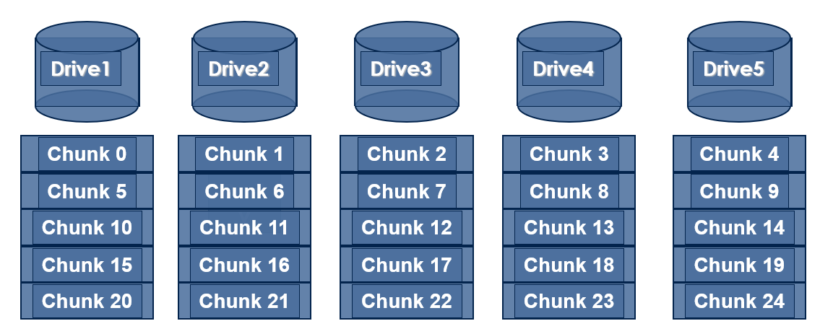

Exercise 2 (Menti): Which statement about RAID 0 is incorrect?
A) High read throughput B) High write throughput
- High reliability D) Any disk failure results in data loss

Exercise 3: (1) If one disk’s bandwidth is 50 MB/Sec., what is the I/O bandwidth of a RAID-0 system with five disks? (2) What is the I/O bandwidth of a RAID-0 with 100 disks?

Exercise 4 (Menti): Which statement about RAID 1 is incorrect?
- Reads are faster since read operations will return after first read is complete.
- Writes are faster because write operations return after second write is complete.
- System continues to work after one disk dies.
- Capacity is n/2 × total disk size.

Exercise 5: Given four disks in a storage system, how will you apply the disk mirroring technique?

Exercise 6 (Group Discussion): What is a problem with disk mirroring? How to solve this problem? (Hint: Think about capacity.)

